Labelling of power system states

By Edgar Mauricio Salazar Duque & Tobias Zethoven

For the labelling of the power system states, first, the corresponding voltages and angles of all buses were plotted. The result can be seen in Figure 1 below. The power system topology was displayed in Figure 2.

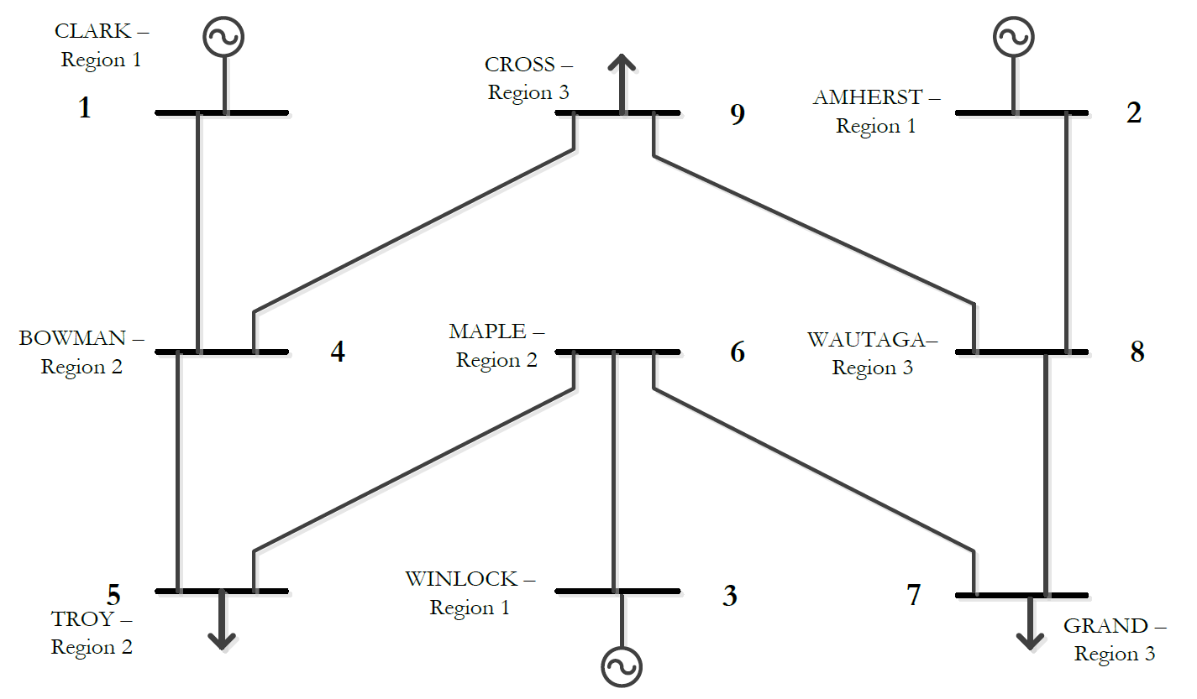

Figure 2: Power system topology.

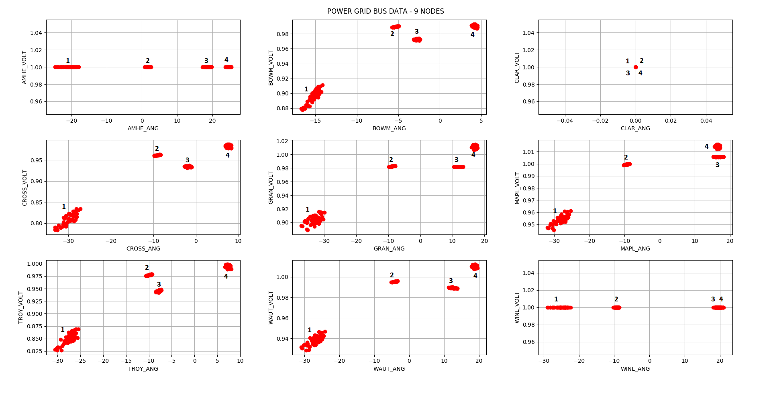

Figure 1: Plots of the measurement dataset.

Considering the first system state, *“High load rate during peak hours”*, it can be expected that the voltage is significantly lower and the current is lagging in the buses where a load is connected, since the increased current flow towards these buses produce a larger voltage drop over the lines. Regarding the plots, cluster 1 in the bottom left of the plots of the load-buses has a lower voltage than the other clusters in these plots and is clearly lagging. Therefore, this cluster was classified as *“High load rate during peak hours”*.

The second system state, *“Shut down of generator for maintenance”*, would mean that there would be no voltage drop and no difference in angle between one of the generators and the connected bus. This phenomenon can be seen in cluster 2 in the plots of buses *WINLOCK* and *MAPLE*. Therefore, this cluster was classified as *“Shut down of generator for maintenance”* in case of shut down of the generator in *WINLOCK*.

The third system state, *“Low load rate during night”*, should be characterized by an increase in voltage at the buses with loads connected. This behaviour can clearly be seen in cluster 4. Cluster 4 was thus classified as *“Low load rate during night”*.

Finally, the fourth system state, *“Disconnection of a line for maintenance”*, can be detected by looking at the relation of the buses that are connected by lines. By elimination, cluster 3 can be classified as *“Disconnection of a line for maintenance”*. When the plots of *MAPLE* and *TROY* are compared, it can be remarked that for cluster 3, the change in voltage and in the angle over this line are quite large whereas this is not the case for the other clusters. It can thus be concluded that for the data points in cluster 3, this line was probably disconnected.